**CHAPTER ONE**

**INTRODUCTION**

**1.1 Background of the Study**

The process of gathering, compiling, and disseminating demographic, economic, and social data relevant to all inhabitants in a nation or territory at a specific period is referred to as a census. Organising a census, on the other hand, is fraught with complications. It has become a highly sensitive and difficult topic, particularly in Nigeria. The information gathered from various censuses makes it simpler to analyse the past, properly characterise the present, and forecast the future. As a result, it is evident that the collection of reliable information resulting from a census performed across a certain region is required for policy making, development planning, information resource, and political objectives. (Ugwu, 2021).

Because contemporary life is becoming more complicated, there is a larger need to plan housing, schools, roads, transportation, and a wide variety of social and economic needs for the nation. This cannot be done without a complete population count. Some organisations or governments, such as the National Population Commission (NPC), are in charge of census administration. (Vijayaraj & DineshKumar, 2020)

According to Ugwu (2021), Census taking in Nigeria may be dated back to 1966, following the colonization of Lagos by our colonial masters. Several attempts to count Nigeria's population have been made since then. However, these censuses are marked by various challenges as well as purposeful and ill-intentioned attempts to exaggerate population estimates in favour of one geopolitical zone or another. This does not and cannot represent the country's image in terms of human population. As a result of this, the National Population Commission (NPC) was founded using Decree No. 23 of 1989. The idea was to have effective censuses every time, as well as reliable demographic data. It is no doubt that this Commission (NPC) was vested with a lot of powers and functions some of which are;

1. To undertake the periodic enumeration of the nation’s population through census, sample surveys, etc.
2. To establish and maintain the machinery for continuous and universal registration of births and deaths.
3. To collect, collate and publish data on migration statistics.
4. To reach and monitor national population polity and set up a national population information data bank.

In contrast to the manual method, which makes access to data and information very difficult, adequate population records will provide all of the necessary information that is associated with people, such as population size, age structure, educational attainment, labour force, and socioeconomic characteristics.

**1.2 Statement of the Problem**

Traditional paper-based census methods in our region are inefficient, inaccurate, and costly, leading to delayed data availability and compromised decision-making. This necessitates the development of a modern computer-based census system to enhance accuracy, accessibility, and cost-effectiveness. Paper-based systems are vulnerable to data loss and manipulation, hindering critical uses such as urban planning and resource allocation. High operational costs strain government budgets, and slow data collection processes impede timely decision-making. Addressing these issues is crucial for accurate, secure, and efficient census data management, supporting our region's progress and growth.

**1.3 Aim and Objectives of the Study**

The aim of the study is to develop a computer-based census information management system for Kaduna State.

The objectives of this research work are as follows:

1. To design and develop a user-friendly computer-based census information management system that encompasses data collection, storage, processing, and analysis.
2. To implement robust data security measures and data validation techniques to ensure the accuracy and security of census data.
3. To streamline the census process to reduce time and resource requirements by leveraging modern technology and automation.

**1.4 Scope of the Study**

The scope of this study encompasses the development of a computer-based census information management system for Kaduna State that contains all information on the human population and allows for data retrieval whenever it is required in society. It is concerned with the collection, retrieval, and administration of information about persons in society. This study wouldn’t go beyond this.

**1.5 Limitations of the Study**

This study's scope has been constrained by several issues, including:

**Time** - The researcher's busy academic pursuits severely limited the time allotted for research for this study.

**Finance** - The need for a standard working personal computer unit to execute and debug the application software, hindered the quick and simple progress of the task.

**1.6 Significance of Study**

Ultimately, this study is crucial for simplifying the acquisition, storage, and retrieval of human population information. It ensures swift and reliable access to data while prioritizing security, preventing unauthorized access, and minimizing fraud. This not only improves administrative processes but also enhances the overall efficiency and integrity of information management.

**1.7 Project Organization**

The project is divided into five chapters. The outlines are presented below:

**Chapter One: Introduction**

Chapter One introduces this project work, the study's background, the problem statement, the purpose and objectives, the scope of the study, the constraints of the study, the relevance of the study, the project organization, and the definition of terms.

**Chapter Two: Literature Review**

This chapter focuses on the literature review, and the contributions of other scholars on the subject matter being discussed.

**Chapter Three: Methodology and Design**

This chapter is concerned with the presentation of the results of system analysis and design. It presents the research methodology used in the development of the system to facilitate an understanding and effective future implementation of the system.

**Chapter Four: System Implementation Evaluation**

This chapter describes the system implementation and documentation, analysis of modules, and system requirements for implementation.

**Chapter Five: Summary, Conclusion, and Recommendation**

The chapter provides a summary of major findings, conclusions, and recommendations based on the study conducted.

**1.8 Definition of Terms**

1. **DEMOGRAPHY**: Demography is the scientific study of the changing number of births, deaths, diseases, etc in a community over a period of time.
2. **POPULATION**: Population is the total number of people living in a particular area, city or country.
3. **CENSUS**: A census is the procedure of systematically acquiring and recording information about the members of a given population.
4. **ENUMERATION**: Enumeration is the head-to-head count of all individuals in a given society within a period of time.
5. **MIGRATION**: Migration is the act of moving from one region or country to another. It is the movement of a group of people, births, or other animals that move in group from one region to another.
6. **ESTIMATION**: Estimation is the act of making an approximate calculation of something.
7. **PROJECTION**: A projection is an estimate of the rate or amount something.

**CHAPTER TWO**

**LITERATURE REVIEW**

**2.1 Introduction**

The purpose of this chapter is to show how the problem under consideration relates to prior research, current practice, or other fields of knowledge by citing relevant works by other researchers who have dealt with a similar issue. Furthermore, this chapter will include a synthesis of current research on the issue, highlighting areas of agreement, disagreement, and gaps in the literature, to establish the significance of the project topic in the field and to recommend opportunities for future study.

**2.2 Literature Review**

(Olugbenga, Maria, & Charles, 2021). Design and Implementation of a Secured Census Information Management System. The process of conducting a census in numerous countries has encountered challenges arising from both natural and human-made barriers. In response to these challenges, the objective of this research is to create a systematic, coordinated, and responsive database. This database is designed to seamlessly interact with a web application, leveraging the capabilities of computational science and biometrics. The emphasis is on developing a robust and efficient system that not only addresses the obstacles faced in traditional census methods but also incorporates technological advancements. By integrating computational science, the research aims to enhance the efficiency of data processing and analysis, ensuring a more streamlined and accurate census.

Furthermore, the tools and programming language used in the creation of this web-based application were chosen for their applicability in handling the challenge at hand. The C# programming language on the.NET platform seems to be the most suited. C# was chosen for its versatility, efficacy, and convenience of incorporating biometrics modules and functionality into the web-based application created with it.

In conclusion, we firmly believe that the adoption and widespread implementation of this system prototype will result in a secure, safe, and reliable database. This, in turn, will contribute to the successful execution of national and economic policies. The robustness of the system is expected to provide a foundation for trustworthy data, fostering confidence in policy implementation at a broader scale. The assurance of data safety and reliability is crucial for informed decision-making, ensuring that the adopted policies effectively contribute to national and economic development.

(Vijayaraj & DineshKumar, 2020). Design and Implementation of Census Data Collection System using PDA. This research focuses on increasing the efficiency of census data gathering. An authorised enumerator collects census data manually using paper and pen in the traditional census data collecting procedure. This procedure has proven time-consuming and labor-intensive. In today's data communication environment, a client tool for a portable system is required to access and update a database. Innovative thought assists us in improving the current system. So the researchers decided that employing a PDA would be the best answer for this handicap.

Moreso, the system design will be established, incorporating Server 2005 Compact Edition (SSCE) as the data storage engine and outlining the features of a PDA client tool. The PDA client tool will be developed, focusing on efficient data collection and updating, leveraging SSCE capabilities for complex query processing, transactions, replication, and data security. The final step includes the implementation of the system by providing PDAs equipped with the census application to authorized enumerators. This approach aims to streamline the data collection process, enhance efficiency, and reduce costs associated with census activities.

In conclusion, our paper on "Census Management with PDA" demonstrates the efficacy of utilizing modern technology, specifically PDAs, for the enumeration and meticulous presentation of census data with minimal hardship. The ease of enumeration and the precision in data presentation underscore the potential benefits of implementing such a system, particularly in vast countries like India. The proposed system not only saves time and minimizes expenditure but also ensures the accuracy of collected data. As preparations are underway for India's 15th census, the integration of new methods like biometrics, including fingerprints and photographs, indicates a commitment to advancing data collection techniques. Our paper, advocating for the use of PDAs in census management, holds relevance in this context, offering insights that can be valuable for maintaining the National Population Register (NPR) during the upcoming census. The application of innovative technologies, as discussed in our paper, is pivotal for achieving more efficient, cost-effective, and accurate census processes in the evolving landscape of demographic data collection.

(Ugwu, 2022). Computer-Based Census Management System: A Case Study of National Population Commission (NPC). Recognizing the tedious and time-consuming nature of manual processes, the researcher conducted a thorough study of the existing system. The Structured System Analysis and Design Methodology (SSADM) was employed and explained in the report. The high-level model of the proposed system was architecturally designed and presented in a user-friendly format. Comprising four modules, each catering to specific functions, including staff and department management, as well as individual registration at various levels (person, states, and Local Government Areas), the proposed system aimed to streamline census activities. The adoption of the parallel changeover methodology allowed for a comparative analysis of results between the old and new systems before implementation, ensuring a smooth transition.

Furthermore, in conducting this research, the researcher effectively employed the Structured System Analysis and Design Methodology (SSADM), focusing on three key techniques: logical data modeling, data flow modeling, and entity/event modeling. The database for the project was built using MYSQL, a relational database management system known for its compatibility with various programming languages. MYSQL was chosen for its ease of record access and manipulation from application development perspectives. The software development phase utilized Visual C-Sharp .Net due to its compatibility with multiple operating systems, object-oriented nature, and a combination of features from Java and Visual BASIC. C-Sharp runs on the Visual .Net platform, ensuring cross-platform compatibility and system security, making it a suitable choice for the project's objectives.

In conclusion, after a thorough study of the existing system and the subsequent design of a new system, the imperative need for the computerization of the organization has been emphatically underscored. Computers possess unparalleled capabilities to store, update, and retrieve information in a manner that surpasses human capacity. The application of computers in census operations addresses the challenges inherent in manual systems, offering advantages such as increased processing speed, improved storage facilities, and simplified data retrieval. Moreover, the computerization of census activities eliminates the logistical challenges of transporting data through vehicles, replacing it with the efficiency and connectivity provided by computer networks. In light of these advantages, it is evident that the computerization of census activities is a highly welcomed development that not only enhances the accuracy and reliability of results but also brings about efficiency and modernization in data processing and management.

(Mauro, Maura, Marco & Giulia, 2019). A web-based management system for addressing census complexity: the Italian experience. The Population Census is a complex survey, and recent Italian Censuses have introduced methodological innovations, transitioning toward a register-supported census and providing various ways for respondents to submit questionnaires. These innovations, while enhancing flexibility, also introduce complexities and potential errors. The challenge lies in conducting a quality census that is both methodologically innovative and cost-effective. The Italian Statistical Institute (Istat) addresses this challenge by proposing a census focused on web technologies. This paper outlines how an integrated web information system, utilizing standard software frameworks and best practices, has effectively managed the census workflow, involving multiple phases, integrating diverse data sources, and engaging various stakeholders. The success of this web-based approach in the Population Census has prompted Istat to adopt the same technological infrastructure for the 'Continuous Population Census.'

Moreso, the development team enhanced the software's security and overall quality, leveraging Java as the primary language. The adoption of a Model-View-Controller design and the incorporation of open-source frameworks, particularly Struts2, Spring, and Hibernate, played a crucial role. Hibernate, in particular, simplified database interaction by providing a layer that works with database tables through a Java object model, expediting development and making the code cleaner and more maintainable. The implementation also extensively used AJAX, a JavaScript-based technology, to facilitate real-time interactions between the graphical user interface and server-side components, enhancing user controls and system responsiveness.

In conclusion, the System of Generalized Registers (SGR) has played a crucial role in supporting the 2020 Italian Population Census, handling daily access by over a hundred thousand users and efficiently managing millions of online questionnaires. While specific measurements on survey quality are pending, SGR has demonstrated its effectiveness in achieving a cost-effective and high-quality census. Notably, SGR's contributions include facilitating a register-based census, reducing errors, providing a structured workflow, and catering to users with diverse responsibilities. Initially adopted in the 2018 Agricultural Census, SGR has proven adaptable and efficient, extending its use to the 2020 Industry and Services Census and serving as the foundation for additional web systems. As part of Istat's technological innovation plans, SGR is set to be generalized for the management of various surveys, including the pivotal 'Continuous Population Census,' aligning with Istat's strategic objectives.

(Baffour, Tom & Valente, 2012). The modern census. The population census is intended to give data on the population and its characteristics. This information is a critical input utilised as the foundation for a wide range of planning choices in a country, and its quality is critical. It also helps to underlie the national statistical system, with the census population data serving as a denominator for many other statistics, such as per capita GDP. However, because of the fast-changing speed of modern life, as well as the increased mobility of the people to be counted, the old census, which counted the resident population, has had to change, and so the concept of quality must be broadened beyond raw accuracy.

In conclusion, the census, while evolving to meet modern societal needs and control costs, remains a vital source of population statistics. Quality considerations go beyond accuracy, encompassing relevance, timeliness, accessibility, interpretability, and coherence. Despite variations in approaches, the census is crucial for national apportionment and representation in democracies. Imperfections exist, but thorough evaluation is essential for maintaining its benchmark status. Periodicity may vary, but individual enumeration remains a core objective, ensuring the census's continued role as a fundamental reference for sampling frames and population strata in sample surveys.

**2.3 Summary of Related Literature Reviews**

|  |  |  |
| --- | --- | --- |
| **Author & Year** | **Title & Description** | **Merit and Demerits** |
| (Olugbenga, Maria, & Charles, 2021). | Design and Implementation of a Secured Census Information Management System.  The study emphasizes on developing a robust and efficient system that not only addresses the obstacles faced in traditional census methods but also incorporates technological advancements. | Location constraints in the compilation of information were eliminated.  The system is limited only to the web. |
| (Vijayaraj & DineshKumar, 2020). | Design and Implementation of Census Data Collection System using PDA.  This research focuses on increasing the efficiency of census data gathering. An authorized enumerator collects census data manually using paper and pen in the traditional census data collecting procedure. | The system streamlines the data collection process, enhance efficiency, and reduce costs associated with census activities.  The technology used are no longer in vague. |
| (Ugwu, 2022). | Computer-Based Census Management System: A Case Study of National Population Commission (NPC).  The researcher conducted a thorough study of the existing system and aimed to streamline census activities | The system addresses the challenges inherent in manual systems, offering advantages such as increased processing speed.  The system might lack scalability, high influx of users might make the site slow. |
| (Mauro, Maura, Marco & Giulia, 2019). | A web-based management system for addressing census complexity: the Italian experience  This paper outlines how an integrated web information system, utilizing standard software frameworks and best practices, has effectively managed the census workflow, involving multiple phases, integrating diverse data sources, and engaging various stakeholders | The system objectives was met  The system is limited only to the web. |
| (Baffour, Tom & Valente, 2012). | The modern census.  The main aim of this research work is to provide information on the population and its characteristics. | The system helps to underlie the national statistical system. |

**2.4 Analysis of the Current System**

The existing approach relies on manual the traditional paper-based methods. The manual approach proves to be inefficient, prone to inaccuracies, and entails high operational costs. One of the major drawbacks is the delayed availability of data, compromising timely decision-making. The vulnerability of paper-based systems to data loss and manipulation poses serious threats to the integrity and security of census information. Furthermore, labor-intensive and slow data collection processes impede the overall efficiency of census operations. These issues collectively hinder the accurate management of census data, impacting the progress and growth of the region.

**2.5 Analysis of the New Proposed System**

The proposed computer-based census information management system represents a significant advancement over the current manual approach, aiming to address the inefficiencies of traditional paper-based methods. By introducing modern technology and automation, the new system seeks to streamline data collection, enhance accuracy, and improve accessibility while minimizing the risks of data loss and manipulation. The integration of robust security measures ensures the protection of census data, contributing to a more reliable and secure information management process. Overall, the proposed system holds the promise of revolutionizing census operations, offering efficiency gains, and reinforcing the accuracy and integrity of demographic, economic, and social data, thereby supporting the progress and growth of the region.

**CHAPTER THREE**

**Methodology and Design**

**3.1 Introduction**

A methodology is a rigorous study or inquiry, particularly to unearth new facts or information; thus, research methodology should be good enough to enable the achievement of the specified objectives, which are achievable using specific components, such as data collection and design procedures, and system modeling (use case, activity, and class diagrams). This chapter provides the input/output specifications as well as the system requirements for developing a computer-based census information management system for Kaduna State.

**3.2 Methods of Data Collection**

Before constructing any system, it is necessary to collect data and facts about the existing system to comprehend what is going on. Two approaches were used in this study.

1. Observation of the Work Environment
2. Documentation

**3.2.1 Observation of the Work Environment**

By monitoring how the manual system worked, this method was employed to acquire information and data for this study. A careful review highlighted the most evident flaws in the current system. When utilizing the observational approach, the environment in which the observation is taken can be changed in a variety of ways.

**3.2.2 Documentation**

Documentation is part of secondary data collection. In this case, journals, manuals, past work, publications, and other sources are utilized. This method of data collection was chosen because it allows for comparison with past studies. This includes the internet, which is a data collection tool. The internet was used to study difficult or ambiguous situations.

**3.3 System Modeling**

A system model is a conceptual model of a system that explains and depicts it. A system is any interaction between a group of components that work together to achieve a common purpose. A collection of visual notation techniques inherent in the Unified Modeling Language, which was used to design this current system, may be used to construct visual models of object-oriented software-intensive systems. UML diagrams utilized in this new design include use case diagrams, class diagrams, and activity diagrams.

**3.3.1 Use Case Diagrams**

Use cases are groups of interactions between a system and a user. Use case diagrams are used to graphically portray the functioning of a system in terms of its actors, goals (expressed as use cases), and dependencies between those use cases.

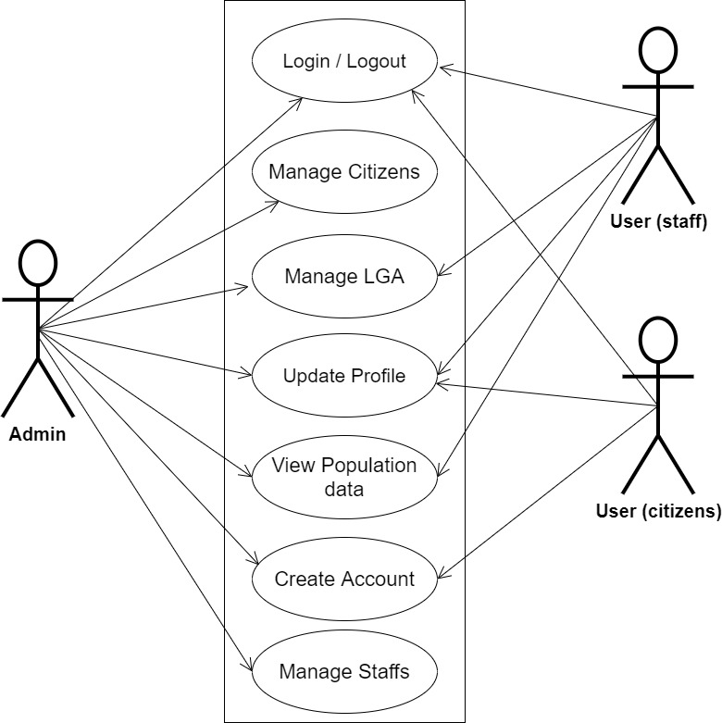

**Figure 3.1 System Use Case Diagram**

**3.3.2 Class Diagrams**

The Unified Modeling Language (UML) class diagram is an implementation of an independent view of how the system interface might appear, with each class having its own set of properties and displaying how they interact with one another. Class diagrams use the Unified Modeling Language standards to visually depict the static structure and composition of a given system (UML).

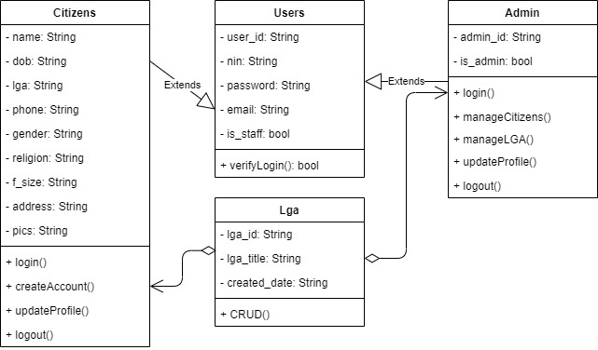

**Figure 3.2 System Class Diagram**

**3.3.3 Activity Diagrams**

An activity diagram, like a flowchart or a data flow diagram, visually illustrates a series of events or the flow of control in a system, but it acts more like an enhanced version of both.

**Login**

The process for gaining access to the system is depicted in the diagram below; the username and password must be accurate to gain access.

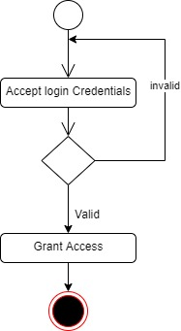

**Fig 3.3 Login Activity Diagram**

**Register Citizens**

The process for creating an account for citizens is depicted below, to create a account one has to be authenticated and must have proper authorization.

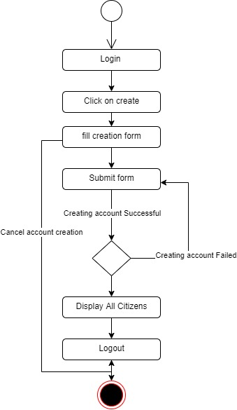

**Figure 3.4 Register Citizens Activity Diagram**

**3.4 Database Design**

Input specification is the logical explanation of how data is stored in the computer's memory. SQL standards are vital for guaranteeing that structured data is uniform and independent of applications due to the flexibility experienced when using the system, as well as the simplicity of accessing and reading the data and ensuring applicability throughout the internet. The following are some of the input specifications used in this project effort.

1. Users Table: contains basic information about all system users.
2. Citizens Table: contains every system-saved citizens information.

**Table 3.1 Users Input Specification Table**

|  |  |  |  |  |  |
| --- | --- | --- | --- | --- | --- |
| **Field Name** | **Data Type** | **Null** | **Key** | **Length** | **Description** |
| user_id | Varchar | No | PK | 32 | Unique string for identifying users |
| nin | Varchar | No |  | 10 | User NIN number |
| password | Varchar | No |  | 128 | User Password |
| email | Varchar | No |  | 100 | User email |
| is_staff | Bool | No |  | 5 | User profile picture |

**Table 3.2 Citizens Input Specification Table**

|  |  |  |  |  |  |
| --- | --- | --- | --- | --- | --- |
| **Field Name** | **Data Type** | **Null** | **Key** | **Length** | **Description** |
| citizen_id | Varchar | No | PK | 32 | Unique string identifying notice |
| name | Varchar | No |  | 100 | Citizen fullname |
| dob | Date | No |  | 100 | Citizen date of birth |
| lga | Varchar | No |  | 30 | Citizen local government |
| phone | Varchar | Yes |  | 11 | Citizen phone number |
| gender | Varchar | No |  | 8 | Citizen gender |
| religion | Varchar | No |  | 20 | Citizen religion |
| f_size | Varchar | No |  | 10 | Citizen family size |
| address | Varchar | No |  | 100 | Citizen address |
| pics | Varchar | No |  | 100 | Citizen picture |

**3.5 Output Design**

This declares and displays the outcome of the given input. This automated system's output is dependent on its input. The output specification is listed below.

**Table 3.3 Users** **output design table**

|  |  |  |  |  |
| --- | --- | --- | --- | --- |
| **User_id** | **Nin** | **Password** | **email** | **Is_staff** |
| XXXX | XXXX | XXXX | XXXX | XXXX |
| XXXX | XXXX | XXXX | XXXX | XXXX |
| XXXX | XXXX | XXXX | XXXX | XXXX |
| XXXX | XXXX | XXXX | XXXX | XXXX |

**Table 3.4 Citizen** **output design table**

|  |  |  |  |  |  |  |  |  |  |
| --- | --- | --- | --- | --- | --- | --- | --- | --- | --- |
| **citizen_id** | **Name** | **Dob** | **Lga** | **Phone** | **Gender** | **Religion** | **F_size** | **Address** | **Pics** |
| XXXX | XXXX | XXXX | XXXX | XXXX | XXXX | XXXX | XXXX | XXXX | XXXX |
| XXXX | XXXX | XXXX | XXXX | XXXX | XXXX | XXXX | XXXX | XXXX | XXXX |
| XXXX | XXXX | XXXX | XXXX | XXXX | XXXX | XXXX | XXXX | XXXX | XXXX |
| XXXX | XXXX | XXXX | XXXX | XXXX | XXXX | XXXX | XXXX | XXXX | XXXX |

**3.6 Input & User Interface Design**

This is a graphic depiction of the system interface; it will be designed to be user-friendly, responsive, and visually beautiful. Furthermore, it will be fully secured, thus authentication will be required to see various levels of the information. To help with the designs, a mid-fidelity wireframing program called Draw.io is employed.

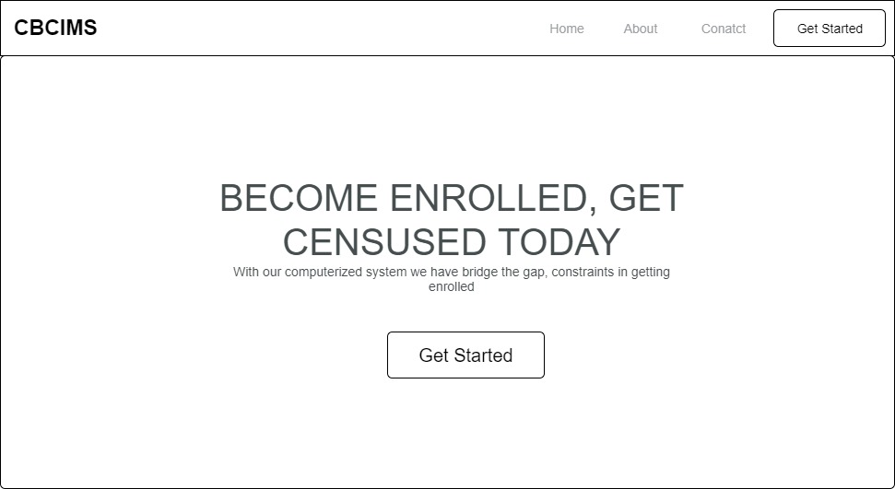

**Figure 3.5 Home Page**

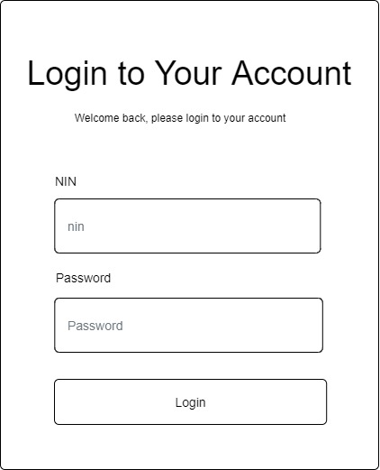

**Fig 3.6 User Login Screen**

**3.7 System Requirement**

Every piece of software has predefined system requirements that it must fulfill to function properly. The system requirements, on the other hand, are the bare minimum of hardware and software required for the system's intended operation.

**3.7.1 Hardware Requirement**

System Hardware Requirement Include:

1. Minimum of 2 GB of RAM (Random Access Memory).
2. Minimum of Intel Dual core processor.
3. Minimum of 250GB HDD (Hard Disk Drive).

**3.7.2 Software Requirement**

The software requirements include:

1. At least windows 7 OS (Operating System).
2. Vs. Code IDE installation.
3. Browsers include Chrome and Firefox.

**3.8 Choice of Programming Language**

This research work will be a web-based application and will be implemented on a relational database system (SQLite). HTML (hypertext markup language), CSS (cascading style sheet), and JavaScript for the frontend development while Django (Python) will be employed for the backend programming.

**REFERENCES**

Baffour, B., King, T., & Valente, P. (2022). The modern census. Southampton

Statistical Sciences Research Institute (S3RI)

Mauro, B., Maura, G., Marco, S., & Giulia, V. (2019). A web-based management system for

addressing census complexity: the Italian experience. Italian Statistical Institute

Olugbenga, O., Maria, K., & Charles K., A. (2021). Design and Implementation of a Secured

Census Information Management System. Egyptian Computer Science Journal, 1(35)

Ugwu, V., C. (2022). Computer Based Census Management System: Caritas University,

Department of Computer Science.

Vijayaraj, A., & DineshKumar, P. (2020). Design and Implementation of Census Data Collection

System Using PDA. International Journal of Computer Applications, 9(9), 28–32. https://doi.org/10.5120/1412-1907